Web Application Firewall Custom Protection Rules with ORM Stack

Contents
1. Introduction 3
2. Workflow diagram to deploy the stack 3
3. Create stack for WAF Custom Protection Rules 4
4. Plan the Job 6
5. Apply the Job 7
6. Verify in the Console 8

Introduction

Custom Protection Rules are specific rules created within a Web Application Firewall (WAF) to provide tailored protection for unique or specific threats targeting a web application. These rules allow organizations to customize their WAF configurations beyond the predefined security rules and policies provided by the WAF vendor.

Workflow diagram to deploy the stack

Below diagram shows how the Terraform Artifact are applied in the OCI. While creating a ORM stack, using terraform deliverables Init, Plan and Apply is the flow to provision the resource in the OCI. We can have the deliverables in any of below.

- GitLab/GitHub Repo
- Bitbucket
- Can be in folder/.zip in the local disk
- Object Storage Bucket
- Can be in compartment
- Oracle provided Template



Create stack for WAF Custom Protection Rules

Go to OCI Console Developer Services Resource Manager Stacks select the compartment Create Stack

My Configuration Folder Browse Select the “custom protection rules” folder that contains the terraform Upload

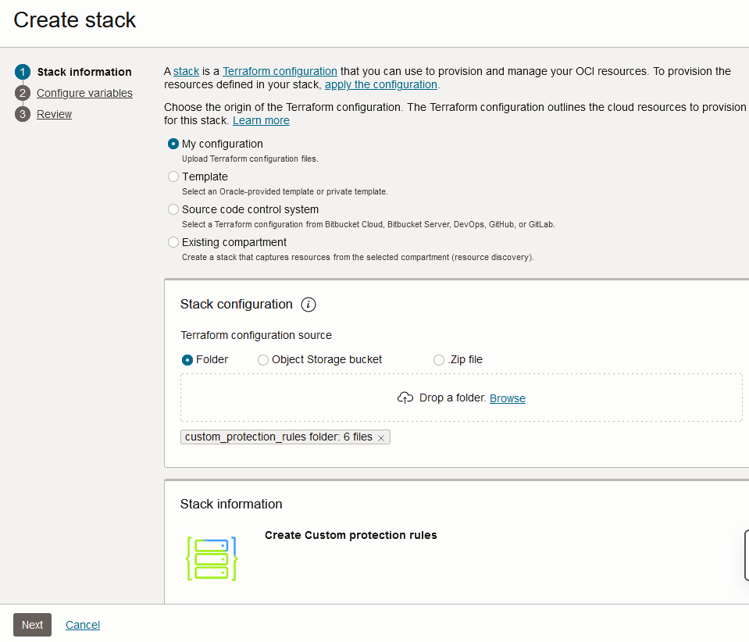

Select the parameters as per the below screens,
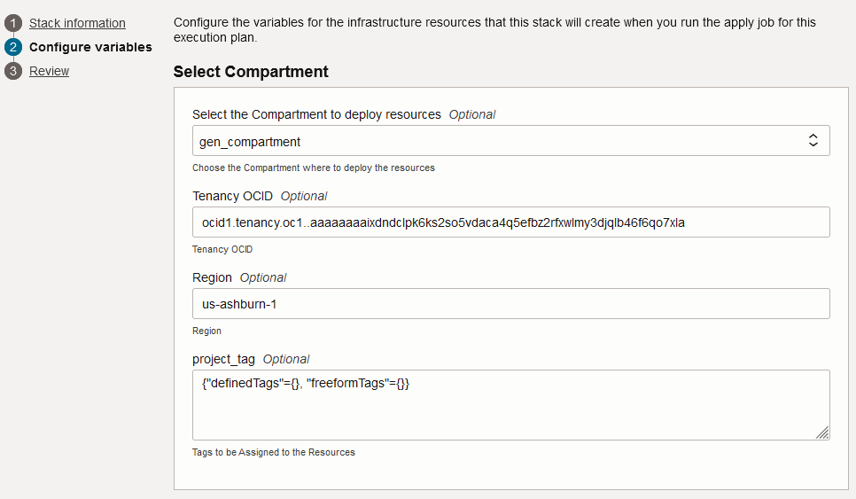

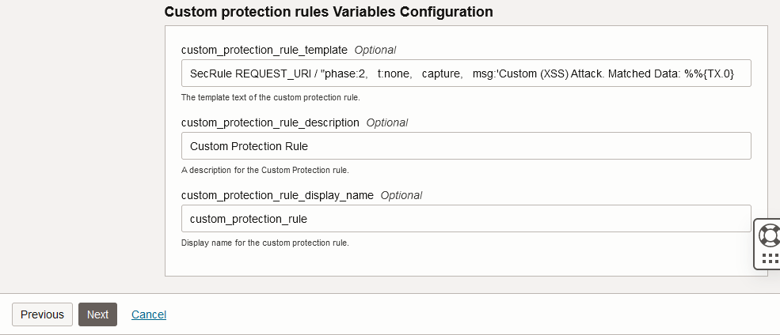

Click “Next”

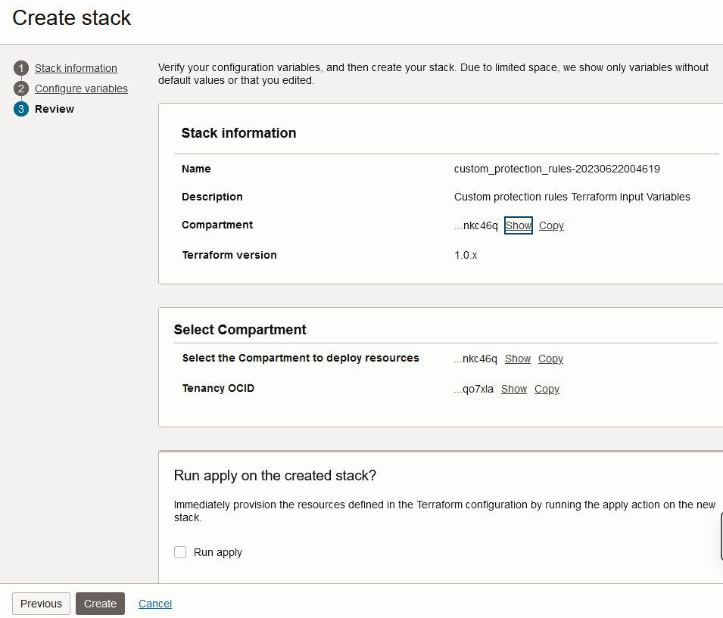
Click “Create”

Plan the Job

Click the “Plan”
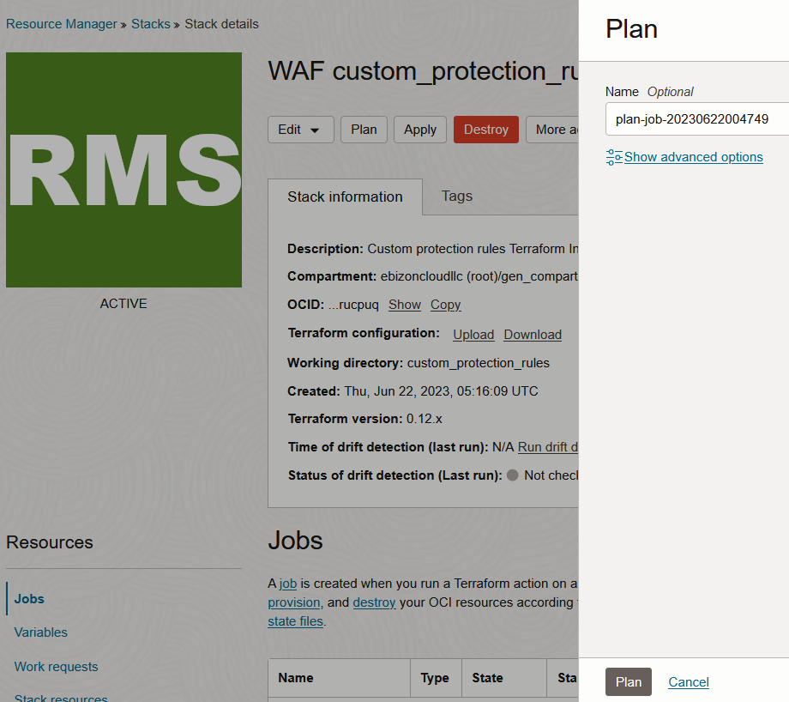

Verify the Plan is successful.

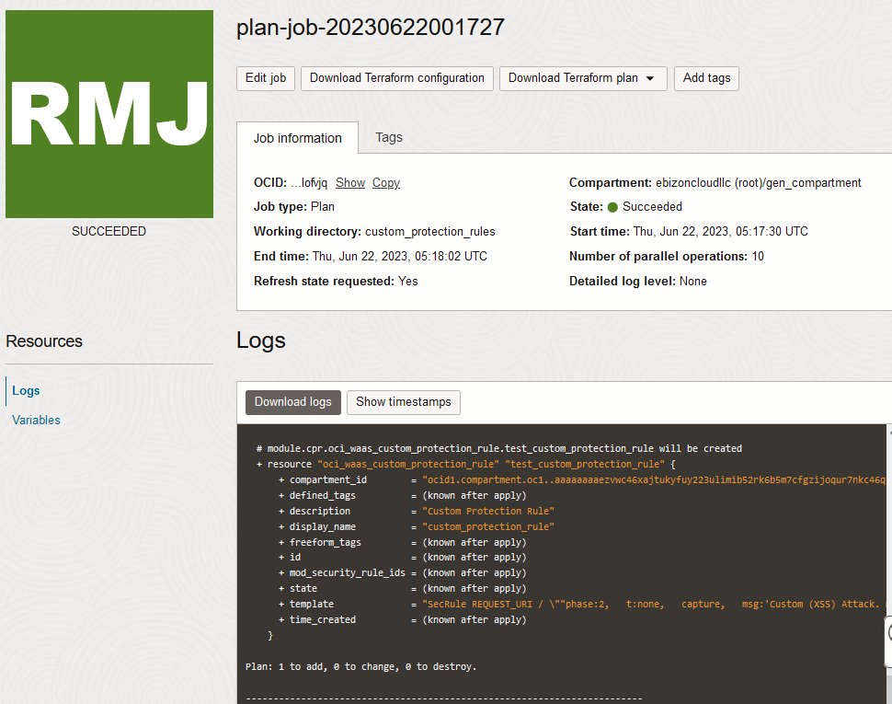

Apply the Job

Once the “plan” is success, now click “Apply”

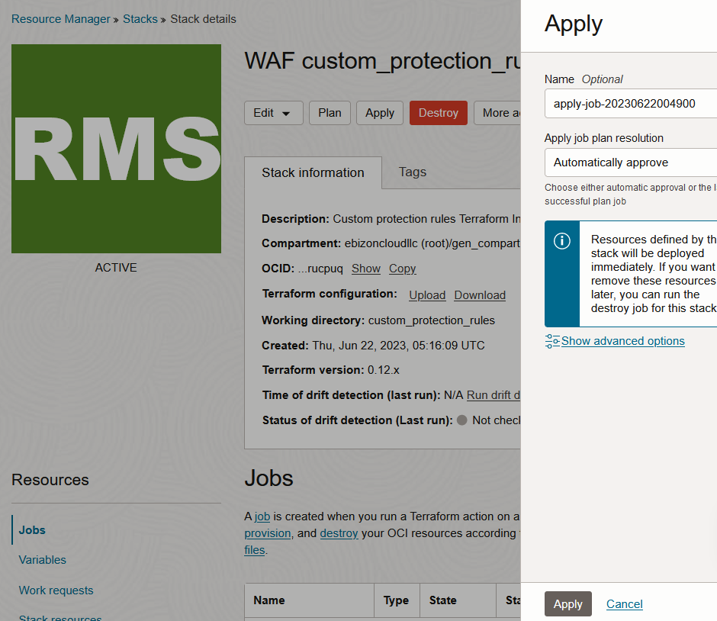
Verify the Apply is successful.

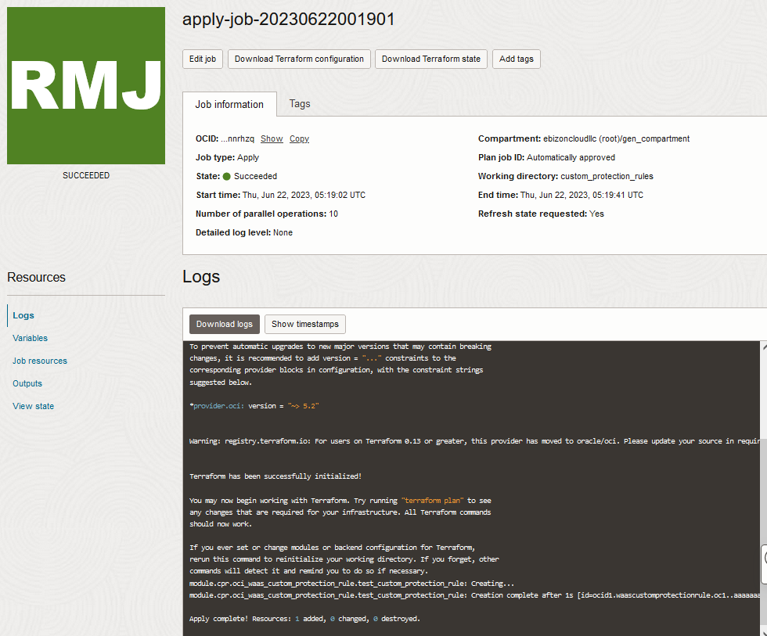

Verify in the Console

Go to OCI Console Web application firewall OCI Edge policy resources Custom protection rules

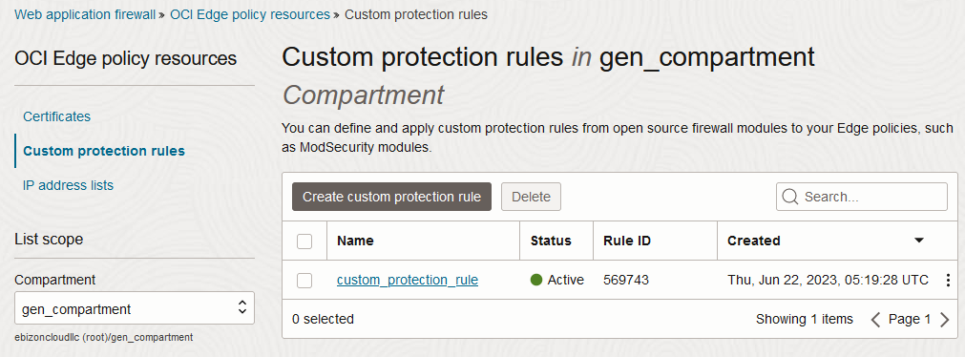
Web application firewall OCI Edge policy resources Custom protection rules Custom protection rules details

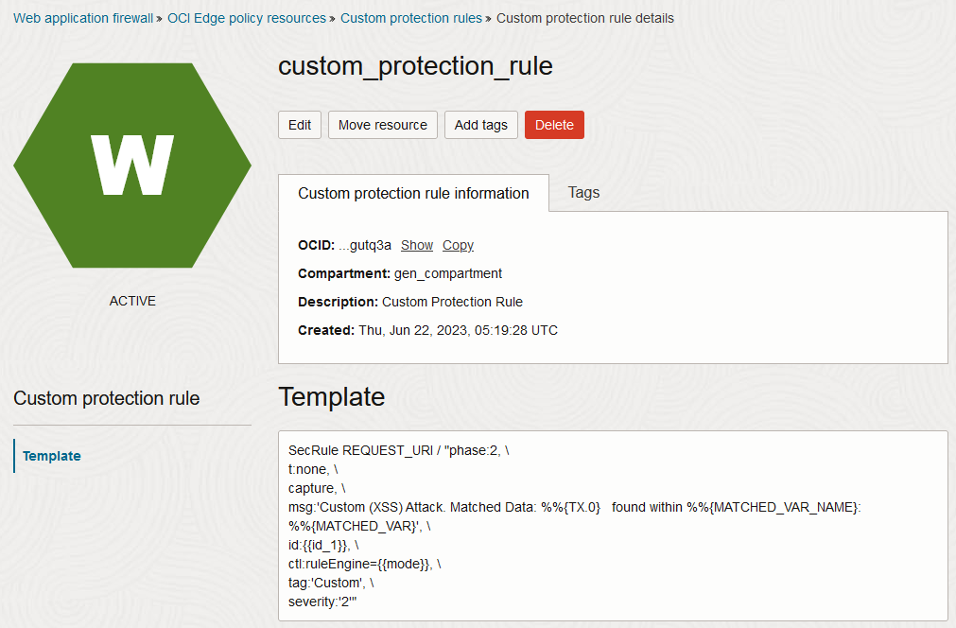

# END #

